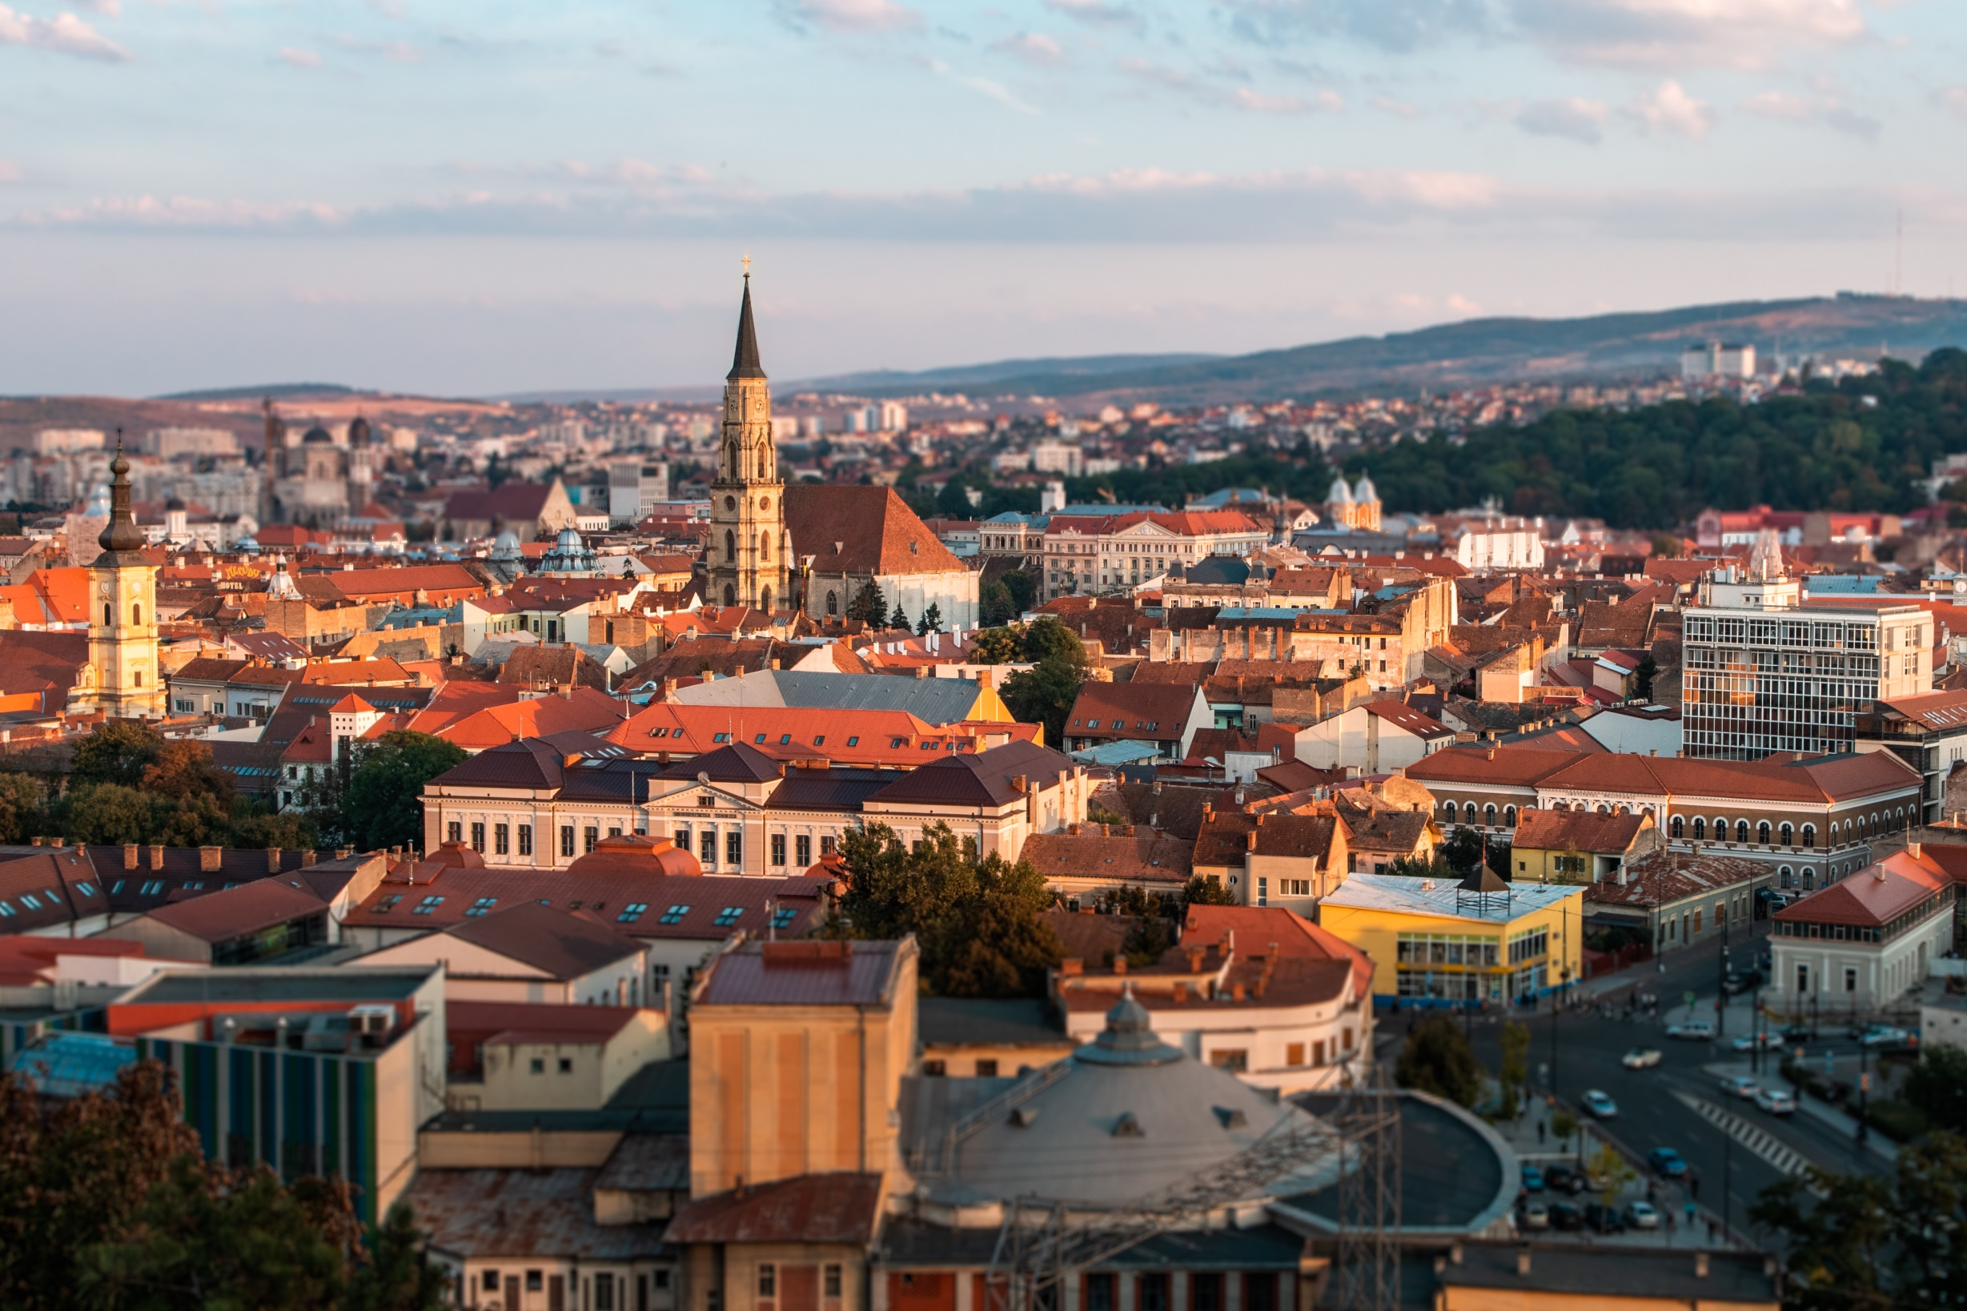

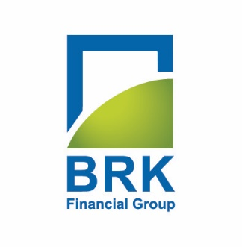
Preliminary
www.brk.ro
SSIF BRK FINANCIAL GROUP S.A. in accordance with International Financial Reporting Standards adopted by the European Union (“IFRS”)
At 31 december 2019
Report

TABLE OF CONTENTS

Identification data | 03
Key indicators | 04
General information about entity | 05
President of the Board’s message | 06
Separate statement of financial position | 07
Separate statement of comprehensive income | 08

Identification data

Legal name SSIF BRK FINANCIAL GROUP S.A.
Field of activity Security and commodity contracts brokerage
NACE Code 6612
Tax Identification Number 6738423
Registered in the Trade Reg under no. J12/3038/1994
Headquarters Address 119 Motilor Street, Cluj-Napoca
Telephone, Fax 0364-401709, 0364-401710
Email office@brk.ro
Webpage www.brk.ro
Securities 337.749.919
Regulated market Ordinary shares with a par value of 0.16 Ron/share
Bucharest Stock Exchange, Main Segment, Premium Tier BSE
Symbol BRK
ISIN ROBRKOACNOR0
Audit The interim financial statements on December 31, 2019 that are
basis of this report have not been audited.

Share indicators

Key indicators
Key indicators |  |  | Evolution
Financial result (Ron) | 31-Dec-19 | 31-Dec-18 | %
Revenue from continuing activities | 21,416,528 | 7,757,230 | 176.08%
Gross operational profit/ loss | 8,168,646 | (2,804,699) | N/A
Gross profit / loss of the period | 8,168,646 | (2,804,699) | N/A
Total comprehensive income of the period | 8,168,646 | (2,804,699) | N/A
Financial position (Ron) | 31-Dec-19 | 31-Dec-18 | %
Tangible asset | 7,770,695 | 8,937,825 | -13.06%
Current asset | 136,918,741 | 97,611,874 | 42.43%
Equity | 144,689,436 | 106,549,699 | 35.80%
Non-current liabilities | 64,429,054 | 54,260,407 | 14.52%
Current liabilities | - | 37,176 | -100%
Tangible asset | 80,260,382 | 50,252,115 | 60.00%
Share indicators | 31-Dec-19 | 31-Dec-18 | %
Earnings per share- EPS (Ron/share) | 0.0242 | (0.0083) | N/A
Net asset value - NAV (Ron/Share) | 0.1908 | 0.1666 | 18.26%
Economic and financial indicators | 31-Dec-19 | 31-Dec-18 | %
Current ratio | 1.71 | 1.94 | -10.83%
Gearing ratio | 1.25 | 0.89 | 34.96%
Non-current assets turnover | 2.76 | 0.87 | 248.75%
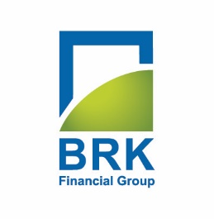

General information about company
SSIF BRK Financial Group SA was established as a joint stock company on October 26, 1994 under the initial name of SIVM Broker SA, and subsequently SSIF Broker SA, until the end of 2015. Due to the expansion of the activity and other financial segments through some strategic acquisitions, but also as a result of internal development, in 2015 it was decided to change the name from SSIF Broker SA to SSIF BRK Financial Group SA Thus, on 21.03.2016, the operation of changing the name was finalized, after the publication of the EGMS decision of 16.12.2015 in the Official Gazette of Romania no. 226, Part IV, on 15.01.2016. The ASF authorization for the name change was received on 24.02.2016.

The head office of the company is located in Cluj-Napoca, while the presence at national level is ensured through the agencies in Bucharest, Timisoara, Iasi and Suceava.

SSIF BRK Financial Group S.A. is a founding member of the Bucharest Stock Exchange, the Romanian Commodity Exchange, and the Investor Compensation Fund
The main activity of the company is the intermediation of financial transactions, BRK being one of the largest brokerage companies in Romania. The company offers a wide range of financial services, intended for both retail and institutional customers. The intermediation of the transactions on the Bucharest Stock Exchange as well as those on other international markets is still one of the main sources of income for the company. Along with the services for the clients, the management of their own portfolio of financial assets contributes to the results of the SSIF BRK Financial Group S.A.

The investments are made both on the Romanian territory and on international markets, both in premium companies listed on regulated markets and in private companies. Thus, SSIF BRK Financial Group S.A. he became a significant shareholder in several Romanian companies, being actively involved in their development. In 2005, BRK Financial Group became the first and, to date, the only financial investment services company listed on the Bucharest Stock Exchange, in the Premium category.
SSIF BRK Financial Group S.A. shares were admitted to trading on the main market administered by the Bucharest Stock Exchange on February 5, 2005 under the symbol BRK. BRK shares are listed on the premium category of the Bucharest Stock Exchange and are included in the composition of the BET Plus index.

President of the Board’s message

Dear shareholders,

BRK Financial Group SA ended a productive year from the perspective of repositioning the company for the future and outlining a unique identity in the Romanian financial market.

The strategy of the company adopted by the General Shareholders Meeting in April 2019 stated that our main orientation is that of an investment company concerned with a high level of performance of its equity, in three strategic directions: investments in innovative technology and IT, the issuance of structured products on the capital markets of Eastern Europe, as well as own investments on regulated markets.

On a secondary level, BRK is obliged to its clients and shareholders to consolidate its position as a top broker in the retail segment, continuing the strategy to become a complete financial 'hypermarket', with brokerage services, portfolio management, corporate finance consultancy and any other investment services created to meet the market needs.

2019 brought the redefinition of the organizational structure in relation to the strategy adopted, by configuring two distinct productive departments, each having experienced management but also the benefits of young and ambitious staff, as well as by reconfiguring the company's IT strategy, oriented towards stable and reliable IT systems.

The result of the ended financial year gives us the confidence that the new positioning of the company was beneficial and on time.

We expect that during 2020 we will complete the restructuring and reconfiguration process, which has as a secondary purpose the reduction and control of fixed operating costs and to realize a significant diversification of the sources of income, so that BRK Financial Group will be a company prepared at any time to face major external risks and, especially, to obtain maximum benefits from future opportunities.

Nicolae Gherguş
Chairman of the Board

Separate statement of financial position as at December31, 2019

In LEI | 31.12.2019 | 31.12.2018
Assets
Intangible assets | 1,213,729 | 1,858,723
Tangible assets | 5,887,007 | 6,160,916
Investment property | 669,959 | 918,186
Financial assets at fair value through other comprehensive income | 44,662,512 | 44,718,868
Loans and advances granted | - | 5,416,511
Trade and other receivables | 14,752,733 | 722,343
Other financial assets | 1,159,937 | 12,267,062
Bank account for clients | 24,773,064 | 31,750,494
Cash and cash equivalents | 53,627,208 | 2,191,875
Assets classified as held for sale | 781,146 | 544,721
Total assets | 144,689,436 | 106,549,699
Liabilities
Financial lease liabilities | - | 37,176
Provisions | - | -
Total non-current liabilities | - | 37,176
Short-term bank liabilities | 4,187,543 | 4,991,870
Current portion of finance lease liabilities | 28,640 | 37,125
Amounts payable to clients (clients’ available funds) | 60,945,094 | 35,942,908
Trade and other payables | 12,296,557 | 9,130,964
Provisions | 2,802,547 | 149,249
Total current liabilities | 80,260,382 | 50,252,115
Total liabilities | 80,260,382 | 50,289,292
Equity
Share capital | 54,039,987 | 54,039,987
Adjustment of share capital | 4,071,591 | 4,071,591
Own shares | (24,047) | (24,047)
Share premiums | 5,355 | 5,355
Reserves from the revaluation of available-for-sale financial assets | 0 | 0
Other reserves | 10,860,687 | 10,860,687
Total reserves | - | -
Current result | 8,168,646 | (2,804,699)
Retained earnings | (12,693,166) | (9,888,466)
Total equity attributable to Company’s shareholders | 64,429,054 | 56,260,407
Total liabilities and equity | 144,689,436 | 99,024,275

These financial statements were approved today, February 26, 2020.

Chairman of the BoA, Accounting Department:
Nicolae Gherguş Sandu Pali

Separate statement of comprehensive income
Reporting as at December 31, 2019
in Lei | 31.12.2019 | 31.12.2018
Continued operations
Revenues from commissions and related activities | 2,964,386 | 3,151,295
Net finance gains other than dividends, : | 13,678,832 | 2,162,486
Net finance gains on transactions with shares and bonds | 4,743,685 | (1,604,123)
Net finance gains on transactions with Turbo products | 1,122,551 | 1,761,567
Net gains on financial assets measured at fair value through profit or loss, unrealised | 7,812,595 | 2,005,042
Financial revenues from dividends | 1,422,354 | 338,370
Financial interest revenues | 2,308,210 | 1,478,985
Income from rentals | 23,690 | 11,652
Net gain on the disposal/decommissioning of property investment | 11,835 | -
Net gain on the disposal/decommissioning of non-current assets | 98,558 | -
Other revenues | 840,839 | 302,614
Revenues from write-off of provisions for risks and charges | 58,702 | 300,933
Total revenues from continued operations | 21,416,528 | 10,205,859
Expenses with employees and collaborators | (4,861,666) | (4,230,034)
Other operating expenses | (459,708) | (411,027)
Expenses with raw materials and consumables | (174,057) | (111,934)
Expenses with power and water | (131,454) | (109,187)
Expenses with taxes and levies | (154,197) | (189,905)
Expenses with suppliers’ services | (3,757,994) | (3,688,786)
Value adjustments of intangible and tangible assets | (982,845) | (1,052,256)
Expenses with allowances for risks and charges | (2,712,000) | -
Expenses with interest | (374,004) | (194,491)
Net finance losses | - | -
Impairment of investments | - | -
Net loss on the disposal/decommissioning of non-current assets | - | (179)
Impairment of receivables | - | (126,464)
Total expenses | (13,247,882) | (10,561,931)
Expenses with provisions for risks and charges | - | -
Result of operating activities | 8,168,646 | (2,804,699)
Profit before tax | 8,168,646 | (2,804,699)
Expenses with income tax | - | -
Profit from continued operations |  | (2,804,699)
Interrupted activities | 8,168,646
Profit from interrupted activities |  | -
Profit for the period | - | (2,804,699)

In LEI | 31.12.2019 | 31.12.2018

Other comprehensive income
Net changes in the fair value of available-for-sale financial assets transferred to profit or loss | - | -
Net changes in the fair value of available-for-sale financial assets
Free shares collected, classified as available-for-sale | - | -
Changes in the value of available-for-sale assets | - | -
Items that cannot be restated to profit or loss | -
Changes in the value of used non-current assets
Changes in the value of investment property |  | -
Set-up/write-off of profit for the allocation of free shares to employees | - | -
Tax on other comprehensive income | -
Total other comprehensive income for the period |  | -
Total profit or loss and other comprehensive income for the period | - | (2,804,699)
 | 8,168,646
 |  | 31.12.2018
 | 31.12.2019

Profit attributable to:
Company’s owners |  | (2,804,699)
Non-controlling interests | 8,168,646 | -
Profit for the period | 0 | (2,804,699)
Total comprehensive income attributable to: | 8,168,646
Company’s owners |  | (2,804,699)
Non-controlling interests | 8,168,646 | -
 | 0
Total comprehensive income for the period |  | (2,804,699)
Earnings per share | 8,168,646
Basic earnings per share (lei) |  | (0.083)
Diluted earnings per share (lei) |  | (0.083)
 | 0.0242
Continued operations | 0.0242
Basic earnings per share (lei) | 0.0242 | (0.083)
Diluted earnings per share (lei) | 0.0242 | (0.083)

Weighted average number of outstanding shares: | 337,749,919 |  | 337,749,919

These financial statements were approved today, February 26, 2020.

Chairman of the BoA, Accounting Department:
Nicolae Ghergus Sandu Pali

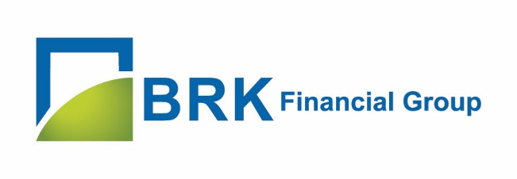
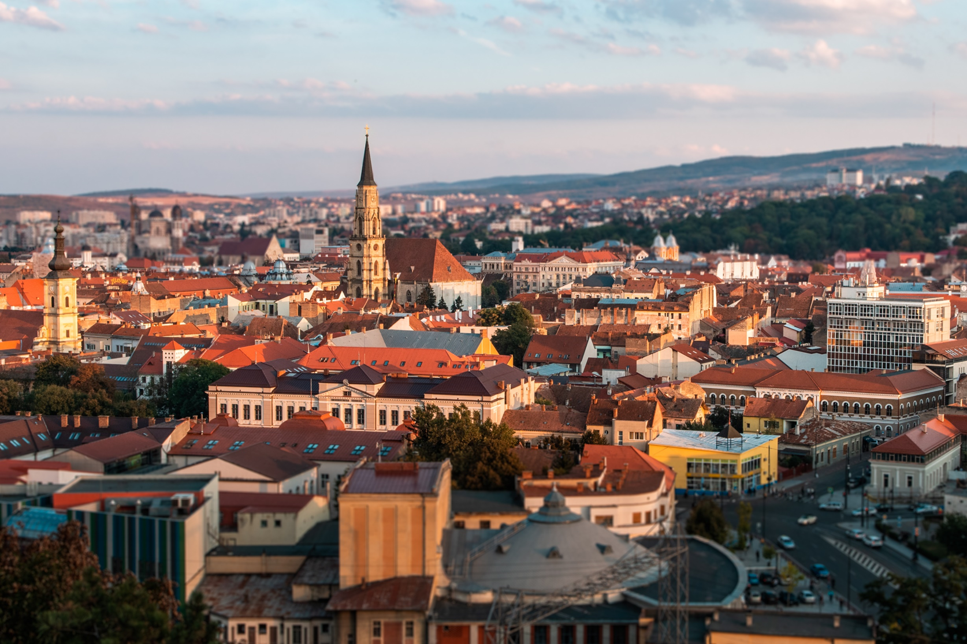

BRK Financial Group
119 Moților Street, Cluj-Napoca, România
+(40) 0364 401 709

office@brk.ro
www.brk.ro

